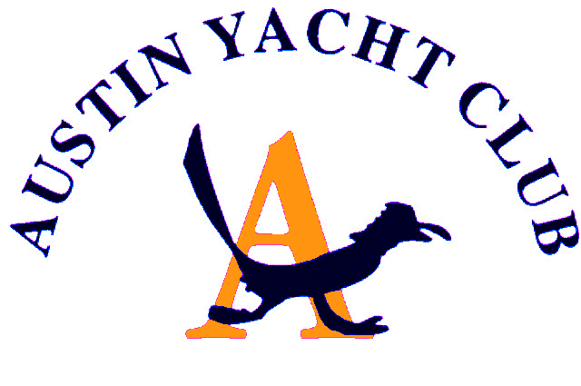
Vice Commodore Report
February 2020

The AYC has had a great start to the new year. The weather has cooperated with the frostbite series and given us some great sailing Saturdays. At the end of the races the social committee has provided us with guest chefs after every race and the special end of series menu provided by our Commodore. The new spring race series has kicked off, and more special “apre” race activities are planned. At the end of this series April 5, Mark and I will be the guest chefs providing a New Orleans feel with seafood gumbo. Other dishes will be provided by volunteers too to round out the theme.
Opening day is this Sunday. Cathie Martin and the social committee have done an extraordinary job planning this event. We have a record 170 + members who have RSVP’d and this event and series race should be a great kick off to the sailing year.
I would like to mention welcoming and working with Bobby Brooks. He and I have met regarding a few issues but mainly regatta planning. He is jumping in feet first and helping me organize the first regatta which will be the traditional Turnback regatta held this year on the weekend of May 16^{h}. I will be searching for volunteers so please contact me if you are interested. More info will come out soon.
There are plenty of other races, and lots of planned fun events this year too, luau, pirate party, etc. so please come out and support all the events. The more the merrier!

Respectfully Submitted,
Diane Covert, Vice Commodore

