Austin Yacht Club
5906 Beacon Drive
Austin, TX 78734-1428
(512) 266-1336

BOARD OF DIRECTOR’S MEETING
Date: February 27, 2020
____________________________________________________________________________________

2020 Social Events

The Frostbite Series has come to an end. The post-race snacks varied from homemade veggie soup, Frito Pie in a Toppers Rhum bucket, Baked Potato bar, Pho with a cooking class the night before and an EOS Dinner with Guest Chef Dane Ohe.

Our expenses were $1,342 with an income of $2,364 giving AYC a net income of $1,033.

For details see Appendix I.

Opening Day Brunch and Ceremony
March 1, 2020

As of February 24th, RSVPs for Opening Day Brunch are:

Yes – 184
Maybe – 17
No – 36
No Reply - 281

The original attendee number was 125 people. We have notified the caterer to increase their number to anticipate 200 attendees. As with all of our events, attendance is weather dependent, and a significant number of members do not RSVP or RSVP late.

The Opening Day schedule is attached as Appendix II. Please encourage members to head downstairs at 10:05 am after Dane announces the ceremony is to start.

$5 $5 $5

Now that we are post-Frostbite Series, the social committee will be serving small plate snacks after mid-series races for $5 a plate downstairs on the patio. The plan is to take left-over/unused food from meals and create tasty treats. The food has been paid for so this option should offer a small income stream and follow where the members are going - downstairs on the patio. The goal is to keep all fleets together after a race, build camaraderie and offer a bite for starving sailors. We found many members were not going or staying upstairs for food when the weather was nice. Initial thoughts on the meal are hot tamales, chicken and dumplings, potato soup with asparagus soup swirl, shepherd’s pie, Mac + cheese and an Adult Root Beer Float (also non-alcoholic). We’ll evaluate our success after the opening series.

Future Events

The next special events after Opening Day are the Luau on May 2, 4th of July Picnic on the 3rd of July, No Rules Chili Wars November 14, a pirate party to be scheduled.

Cathie Martin
Date | Event | Estimated Budget | Actual Expense | Revenue | No. of Attendees (Rev/Non-Rev) | Net Income | Volunteers
Jan. 18 | Frostbite Series  Veggie Soup & Ham Sandwiches for $8.00 | $240 based on 30 attendees | $90 | $328 | 49  (41 Rev/8 Non-Rev) | $238 | Marilyn & Jeff Jackson, Event Leads plus Krissy Amato, Monica Paredes, Amy Gunkler, Linda McDavitt & Fred Ford
Jan. 25 | Frito Pie | $240 based on 30 attendees | $68 | $384 | 52 (48 Rev/4 Non-Rev) | $316 | Annie & Charlie Lancaster, Event Leads, Cathie Martin, Vicki Stone
Feb. 1 | Baked Potato Bar  Featuring Bill Benker | $240 based on 30 attendees | $386 | $560 | 72 (70 Rev/2 Non-Rev) | $174 | Jennifer Hopgood, Event Lead, Monica Paredes, Dave Meredith, Charles Christie, Dave Benker, Bill Benker, Can Kalyoncuoglu, Liz Stansfeld, Sarah Zajicek, Pat Manning
Feb. 7 | Phở Gà (Pho Chicken) Cooking Demonstration with Dee Chow | free member event – 21 attendees |  |  |  | Included in Feb 8 numbers | Dee Chow, Jeff Sabuda, Walter Payne, Cathie Martin, Marilyn and Jeff Jackson, Liz Stansfeld and grandson William
Feb. 8 | Phở Gà | $240 based on 30 attendees | $503 | $472 | 72 (70 Rev/2 Non-Rev) | -$31 | Dee Chow & Jeff Sabuda, Event Leads, Walter Payne, Cathie Martin, Marilyn and Jeff Jackson, Liz Stansfeld and grandson William, Pat Manning
Feb. 15 | Frostbite EOS Dinner – Guest Chef Dane Ohe | 50 attendees | $295 | $620 | 64 (62 Rev/5 Non-Rev)  No. of plates was closer to 78 | $325 | Dane Ohe, Krissy Amato, Karen Bogisch, Sarah Zajicek, Mary Carew, Teri Suarez, Marilyn and Jeff Jackson, Fiona Froelich
 | Totals |  | $1,342 | $2,364 |  | $1,022
March 1 | Opening Day Brunch and Ceremony, Blessing of the Fleet |  |  |  |  |  | Cathie Martin, Pat Manning, Karen Bogisch
April 3 | Laissez Les Bon Temps Rouler! Gumbo Cooking Demo Diane Covert | Free member event- 16 attendees |  |  |  |  | Diane Covert and Mark Zion, Event Lead, Harry Polly, Cajun Gumbo
April 4 | EOS Dinner – Guest Chef Diane Covert’s Gumbo |  |  |  |  |  | Diane Covert & Mark Zion, Event Leads, Monica Parades
May 2 | Luau |  |  |  |  |  | Cathie Martin
May 31 | Spring Series EOS Dinner – Guest Chef Jackie Wheeless | 50
July 3 | July Picnic & Fireworks Viewing | 50 |  |  |  |  | Jennifer Hopgood, Event Lead
Nov. 14 | No Rules! Chili Wars Cook-off & Honor Sail | 50 |  |  |  |  | Dee Chow & Jeff Sabuda
TBD | EOS Dinner – Guest Chef Taylor Snyder, Blue Duck Winner | 50 |  |  |  |  | Taylor Snyder
Nov. | AYC Annual Meeting | 75 |  |  |  |  | Cathie Martin
Dec 5 | AYC Annual Banquet | 120 |  |  |  |  | Dane Ohe, Cathie Martin, Jackie Wheeless
TBD | Sea Scouts Fundraisers
TBD | Road Runner Fundraisers

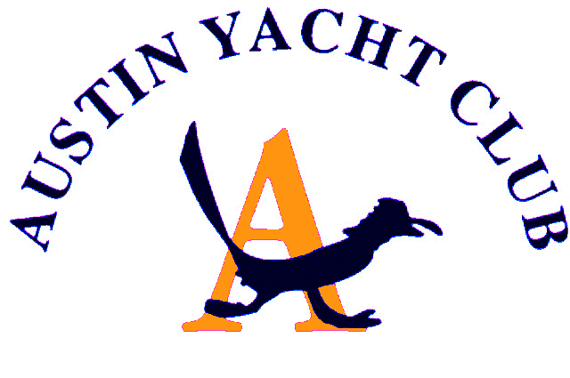
Opening Day Brunch and Ceremony

________________________________________________________________________

Schedule of Events

9:30 am Bloody Mary Bar

10:00 am Brunch

10:50 am Commodore announces to move downstairs and shepherding of people downstairs

10:55 am Bag pipe player begins playing

11:00 am Raising of the Flag by the Sea Scouts using their Boston whistle as the color guard marches in. Flag is raised. Sea Scouts march out.

11:05 am Commodore invites Kate Hennig to sing "The Star-Spangled Banner"

11:10 am Commodore welcomes everyone to Opening Day

11:15 am Commodore invites Clift Price to give the invocation

Clift Price gives invocation and calls out AYC members who have passed away in the last year. Harry Polly rings bell after each name. Bag pipe player plays Amazing Grace

11:25 am Commodore introduces Tom Romberg

Tom Romberg give brief history of the club and its founders

11:40 am Commodore recognizes past commodores, the current board of directors and AYC staff; introduce Bobby Brooks

11:50 am Commodore invites Road Runners to come forward and they sing “Randy Dandy-O”. Road Runners march out while bag pipe player plays Scotland the Brave

12:00 pm End of Ceremony
12:15 pm Skippers Meeting
1:30 pm Race

(Rev/Non-Rev) = No. of Revenue/Non-Revenue Attendees
Includes expenses for free cooking class

