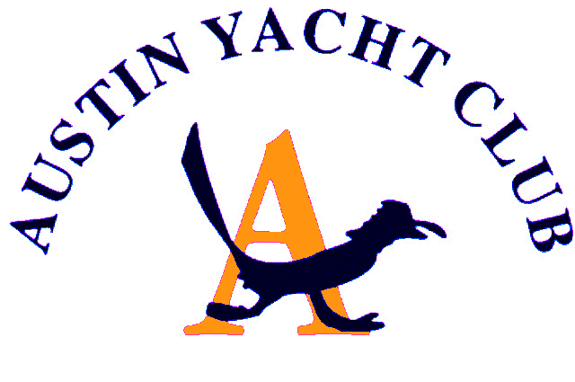
Vice Commodore Report

First, I would like to thank all the AYC members for being so patient with our attempt to sift through all the ever-changing governmental regulations, networking with other yacht clubs and creating the guidelines for the club. We appreciate your constructive feedback. It has been an eye-opening experience made especially difficult when you are not seeing sailors face to face.
The AYC club handbook lists all the rules and regulations that pertain to the club grounds, slips, behavior, etc. Racing has a set of rules that are agreed to by various sailing organizations, but with the COVID crisis, there are no previous guidelines to follow. Researching, sharing info, discussing, and getting professional advice from our own members has been key. We are not unlike every other business, restaurant, school, etc. that are trying to figure out how to reopen and conduct operations safely.
The AYC board and the COVID -19 Advisory Committee have been meeting weekly to discuss these issues. We don’t always agree on every aspect of every item, but the goals we all agree on is that we want to follow the Austin/Travis Co., State regulations , keep exposure risk down, follow CDC sanitation guides, protect the club from liability and for all members to have an equal opportunity to enjoy the club.
My wish, and I bet all of yours, is that this could end soon, and we can sail, race, and have fun like we used to!

Diane Covert, Vice Commodore

