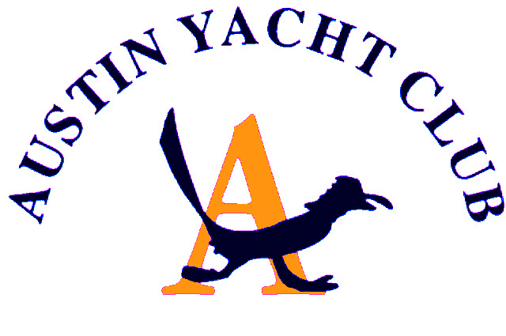
AYC Secretary’s Report
March 2020

A website committee was formed and met to begin planning for an update to both technical and thematic elements of the AYC website. John Grzinch shared that the website last had an overhaul in 2013 and some technical elements are no longer supported and require updating.
Russ Shermer and Ed Pierce were gracious enough to take on the task of researching virtual meeting options for the club to use to facilitate club operations while dealing with the COVID-19 crisis.
Jackie, Suzie and I have been reviewing options for the production of both the directory and TellTale With a current focus on the upcoming issues of the TellTale. Current conversations include special fleet specific articles featuring one or more individual fleets, the boat(s), people and history of each fleet, plus various all AYC announcements and tips for living safe and healthy during the eventless period. A temporary move to digital publication due to the lack of club events and unsettled and unpredictable nature of the upcoming schedule is being considered.

Respectfully,
Gretchen Douglas
AYC Secretary

