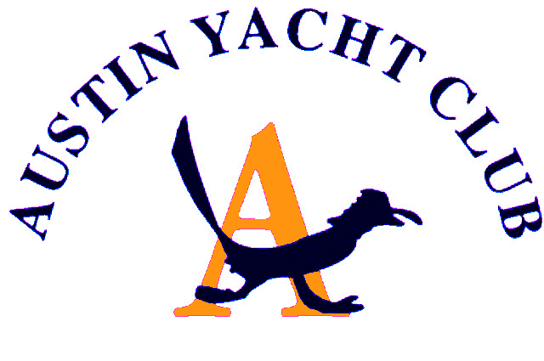
Vice Commodore Report
January 2020

Here we are in a brand-new year and decade! Where did the last 10 years go?
I am honored to be your Vice Commodore this year and transitioning from Building and Grounds will be a huge challenge, but I am so happy that John Maddalozza will be at the B&G helm. I am also looking forward to working with our other new board members, as I know this will be a fun year.
This year’s race calendar has changed a bit from last year. In working with John Parker our new race commander, the AYC sponsored regattas have changed formatting. I am looking for a few volunteers to chair these regattas, so please contact me asap.
The first regatta will be the traditional Turnback regatta held this year on the weekend of May 16^{h}. Notice that it is not on Mother’s day or Memorial day so hopefully we will have more participation and less boat traffic on Lake Travis. At this time Turnback is planned to be linked with Lago Vista’s “ Lagofest” party at the park as it has been in the past. Of course, there are variables such as the lake level and working with Lagofest to finalize the negotiations, but plan on it being held that weekend.
There will be the annual Roadrunner regatta in June which is always a fan favorite.
The big change will be for Governors Cup which is planned for two consecutive weekends in October. The thought is to have the centerboards race a course the first weekend, then the larger boats the race following weekend. Thereby creating one large event combining everyone, similar to the Wurstfest regatta. My thought is that we will still have food and entertainment for both weekends.
There are plenty of other races, and lots of planned fun events this year too, luau, pirate party, etc. so come out and support all the events. The more the merrier!

Respectfully Submitted,
Diane Covert, Vice Commodore

