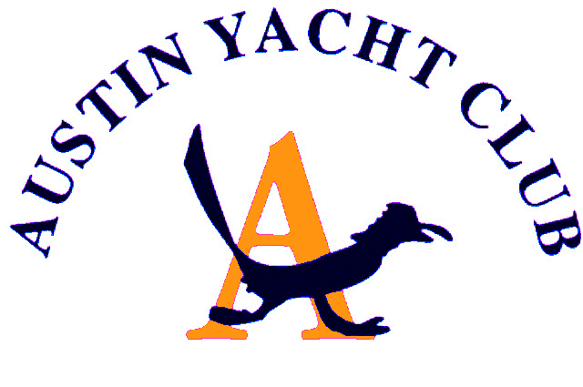
Vice Commodore Report

This month’s report is very short but there are a few things to mention. Of course, with all that is happening in our world, or NOT happening, events are subject to change yet again.
First, the Turnback Canyon regatta is still scheduled for May 16th and 17th and the AYC luau will also be scheduled for that night of the 16th moved from May 2. This planned date may all have to be pushed further out because of the uncertainty of these times.
In addition, we have canceled our participation in Lagofest, anticipating that Lagofest will be canceled. Even if it is not canceled, we wanted time to plan and move the date of our regatta to best serve our members during this time. Combining it with the luau also will save us money. Therefore, our plan will be to have a long-distance race to somewhere near Lakeway on Saturday and again on Sunday with a big party Saturday night. Stay tuned for details.
Let’s hope we can all resume our active and fun times together soon. Stay safe.

Diane Covert, Vice Commodore

